**Ideation Phase**

**Define the Problem Statements**

|  |  |
| --- | --- |
| Date | 19 June 2025 |
| Team ID | LTVIP2025TMID46662 |
| Project Name | Freelance finder |
| Maximum Marks | 2 Marks |

**Customer Problem Statement Template:**

To define the core problems freelancers face while searching for jobs online, and use those insights to guide the development of Freelance Finder.

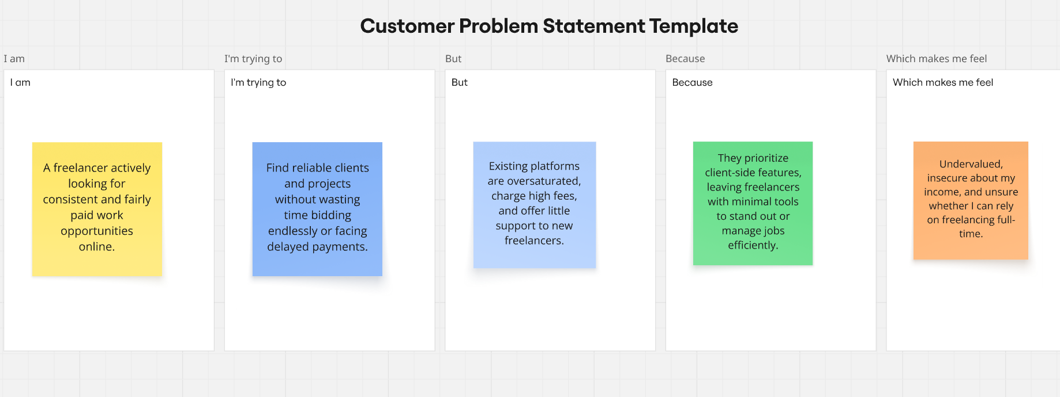

Reference: <https://miro.com/templates/customer-problem-statement/>

|  |  |  |  |  |  |
| --- | --- | --- | --- | --- | --- |
| **Problem Statement (PS)** | **I am (Customer)** | **I’m trying to** | **But** | **Because** | **Which makes me feel** |
| PS-1 | freelance web developer. | land steady projects | competition on mainstream platforms is overwhelming | many clients opt for the cheapest bid | frustrated and demotivated. |
| PS-2 | freelance graphic designer | showcase my portfolio to potential clients effectively, | platform limits personal branding tools |  | I can't stand out or grow my career. |